Yuva Intern AI-Pioneers Internship(Machine Learning Internship) Week 2
Name : Manasvi Beri
Task : Supervised Machine Learning Models

Introduction
Machine learning is a branch of Artificial Intelligence that enables computers to learn patterns from data and make predictions without being explicitly programmed. In this project, supervised machine learning algorithms are implemented using Python and the Scikit-learn library.
The Titanic dataset which is utilised previously is used to predict whether a passenger survived the Titanic disaster based on passenger information such as passenger class, gender, age, number of siblings or spouses, parents or children, fare, and port of embarkation.
Four classification algorithms are implemented and compared: Logistic Regression, K-Nearest Neighbors, Decision Tree, and Random Forest.

Objective
The main objectives of this project are:

- To understand supervised machine learning using Scikit-learn.
- To preprocess the Titanic dataset for machine learning.
- To train classification models using the prepared dataset.
- To make predictions using trained models.
- To evaluate the models using Accuracy, Precision, Recall, and F1-score.
- To generate confusion matrices and classification reports.
- To compare the performance of four machine learning models.

Dataset Description
The Titanic dataset contains information about passengers who travelled on the RMS Titanic. The target variable used in this project is Survived.
The value of Survived represents:

- 0 – Passenger did not survive

- 1 – Passenger survived

The features used for prediction include:

- Pclass – Passenger class
- Sex – Passenger gender
- Age – Passenger age
- SibSp – Number of siblings or spouses aboard
- Parch – Number of parents or children aboard
- Fare – Passenger fare
- Embarked – Port from which the passenger boarded

Data Preprocessing
Before training the machine learning models, the dataset was cleaned and prepared.

Missing values in the Age and Fare columns were replaced using their median values. Missing values in the Embarked column were replaced using the most frequently occurring value.
The categorical variables Sex and Embarked were converted into numerical values using one-hot encoding. This allowed the Scikit-learn models to process the categorical information.
The Survived column was separated as the target variable, while the remaining selected columns were used as input features.
For Logistic Regression and K-Nearest Neighbors, feature scaling was performed using StandardScaler.

Train-Test Split
The dataset was divided into training and testing data.

- 80% of the data was used for training.
- 20% of the data was used for testing.

A random state of 42 was used to make the experiment reproducible.

The training data was used to train the machine learning models, while the test data was used to evaluate their performance on unseen data.

Machine Learning Models

Logistic Regression

Logistic Regression is a classification algorithm used to predict the probability of a class. In this project, it predicts whether a passenger survived or did not survive.
The model was trained using the scaled training data and then used to predict the survival status of passengers in the test dataset.

K-Nearest Neighbors

K-Nearest Neighbors (KNN) is a classification algorithm that predicts the class of a data point based on the classes of its nearest neighboring data points.
A value of k = 5 was used in this project. The model was trained using scaled features.

Decision Tree

Decision Tree is a supervised learning algorithm that makes predictions by splitting the data into different branches based on feature values.
A maximum depth of 5 was used to control the complexity of the tree and reduce the possibilit y of overfitting.

Random Forest

Random Forest is an ensemble learning algorithm that combines multiple decision trees to make a prediction.
In this project, 100 decision trees were used. The final prediction is based on the combined results of the individual trees.

Model Training and Prediction
Each model was trained using the training dataset. After training, the models were used to predict the survival status of passengers in the test dataset.
The predicted values were compared with the actual values from the test dataset to calculate the evaluation metrics.

Evaluation Metrics
The following metrics were used to evaluate the models:

Accuracy

Accuracy represents the percentage of correctly classified predictions out of all predictions.

Precision

Precision measures how many of the passengers predicted as survivors were actually survivors.

Recall

Recall measures how many of the actual survivors were correctly identified by the model.

F1-Score

F1-score is the harmonic mean of precision and recall. It provides a combined measure of the model's precision and recall.

Model Performance Comparison
The performance of the four models was compared using the calculated evaluation metrics.

The values in the table were obtained directly from the model evaluation performed on the test dataset.
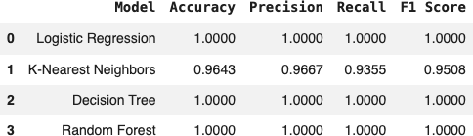

Confusion Matrix
A confusion matrix was generated for each of the four models. The confusion matrix contains four types of results:
- True Positive (TP): Passenger was predicted as survived and actually survived.

- True Negative (TN): Passenger was predicted as not survived and actually did not survive.
- False Positive (FP): Passenger was predicted as survived but actually did not survive.
- False Negative (FN): Passenger was predicted as not survived but actually survived.

The confusion matrices help understand the types of errors made by each classification model.
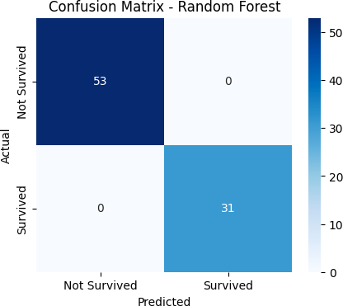
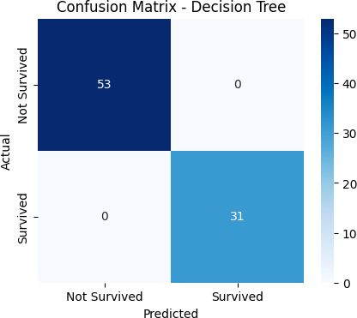
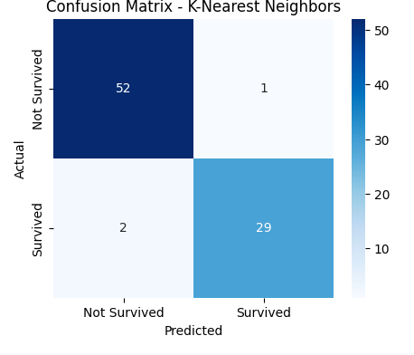
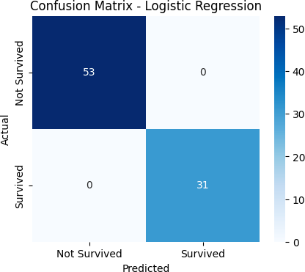

Classification Report
A classification report was generated for all four models. It contains:

- Precision
- Recall
- F1-score
- Support

The classification reports provide a detailed view of the performance of each model for the two classes: Not Survived and Survived.

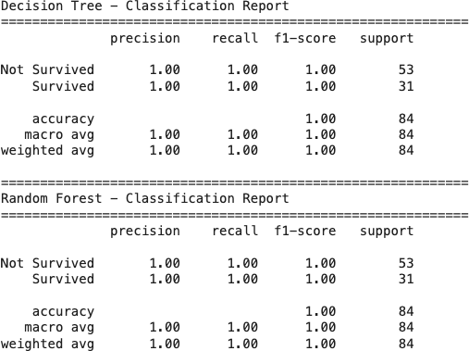
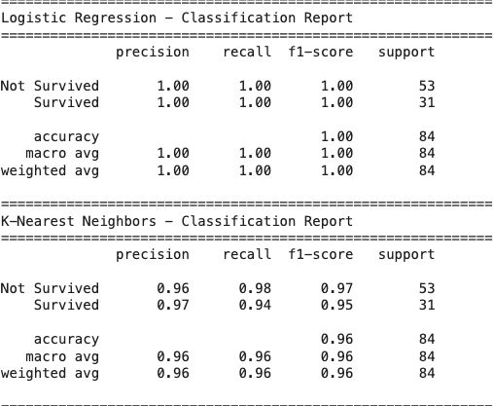

Results and Discussion
Four supervised machine learning classification algorithms were successfully implemented using the Titanic dataset.
Logistic Regression provided a baseline classification model. K-Nearest Neighbors classified passengers based on the similarity between passenger records. Decision Tree used a sequence of feature-based decisions to classify passengers, while Random Forest combined multiple decision trees to produce predictions.

The performance of the models was compared using accuracy, precision, recall, and F1-score. The confusion matrices and classification reports were also analyzed to understand the prediction errors and class-wise performance.
The actual metric values obtained from the test dataset are included in the performance comparison table.

Conclusion
This project successfully demonstrated the implementation of supervised machine learning classification algorithms using Scikit-learn.
The Titanic dataset was cleaned and preprocessed before training the models. Four models—Logistic Regression, K-Nearest Neighbors, Decision Tree, and Random Forest—were trained and evaluated.
The project provided practical understanding of data preprocessing, model training, prediction, and performance evaluation. Comparing multiple models using different evaluation metrics helps understand how different algorithms perform on the same dataset.
Overall, the project demonstrates the complete machine learning workflow, starting from dataset preparation and ending with model evaluation and comparison.

Tools and Technologies Used
- Python
- Google Colab
- Pandas
- NumPy
- Scikit-learn
- Matplotlib
- Seaborn
- Titanic Dataset

Future Enhancements
The project can be further improved by:

- Performing hyperparameter tuning.
- Testing additional machine learning algorithms.
- Using cross-validation for more reliable evaluation.
- Performing feature engineering on the Titanic dataset.
- Creating a simple web application for making predictions for new passengers.

